OIL CONDITION MONITORING REPORT SLNS GAJABAHU

ENGINE PARTICULARS (Information provided by the customer)
 | No 02 Generator (Port)
Make : | GENERAL MOTORS
Model : | EMD 645-E6
Sr. No: | 6T-J1-1113
Date sampling : 28.01.2019 | 25 Jun 25
Sampling point : | Near lub oil strainer
Sampling Method : | Extraction
Type of Lubricant : | Shell Gardinia S3 SAE 40
System Capacity : | 300 USG

RUNNING HRS DETAILS (Information provided by the customer)
 | No 02 Generator (Port)
Sample ID | M010379
Oil Running Hours | 4954.15
After MOH running hrs | 13,250.00
Total Running Hours of the Machinery | 113,549.45

ANALYSIS RESULTS
Basic Properties
Description | Method | Fresh Oil  (As per OEM data sheet) | Uncertainty | No 02 Generator (Port)
 |  |  |  | S/I-M010379
Viscosity @ 40ºC (cSt) | ASTM D 445 | 128.00 | 0.006 | 130.60
Viscosity @ 100ºC (cSt) | ASTM D 445 | 13.7 | 0.005 | 14.32
Viscosity Index | ASTMD 2270 | 103 | N/A | 108.55

Elemental Concentration as per ASTM D5185 (ppm)

Element | Maximum Permissible Limit | Fresh Oil Sample | Uncertainty | No 02 Generator (Port)
 |  |  |  | S/I-M010379
Fe | 80 | <1.000 | 0.15 | 6.248
Cr | 10 | <1.000 | 0.18 | <1.000
Si | 15 | <1.000 | 0.17 | <1.000
Al | 20 | <1.000 | 0.28 | <1.000
Pb | 20 | <1.000 | 0.13 | 2.252
Cu | 25 | <1.000 | 0.17 | 6.956
Sn | 10 | <1.000 | 0.20 | 3.204
Ni | 10 | <1.000 | 0.08 | <1.000

TREND ANALYSIS WITH PREVIOUS REPORTS

 |  | Fresh Oil Sample | No 02 Generator (Port)
 |  | Fresh Oil Sample | S/I- | S/I- |  | S/I- |  | S/I- |  | S/I- | S/I- | S/I- | S/I- | S/I- | S/I- | S/I- | S/I- | S/I- | S/I- | S/I-
 |  | Fresh Oil Sample | M000509 | M00609 |  | M000610 |  | M001096 |  | M01504 | M002045 | M002236 | M002333 | M002379 | M002591 | M002743 | M002826 | M002865 | M002985 | M003047
Oil Running Hrs |  | - | 1108 | 1365.3 |  | 1617.45 |  | 2380.3 |  | 2630.1 | 3031.3 | 3535.25 | 3756.45 | 3822.15 | 4025.45 | 4180.1 | 1786.3 | 1824.3 | 130 | 189.4
T/R/H of Machinery |  | - | 92417.55 | 92685.05 |  | 92935.05 |  | 94171.1 |  | 95421.2 | 95822.4 | 96326.35 | 96547.55 | 96613.25 | 96816.55 | 96971.2 | 97243.45 | 97281.45 | 97508.5 | 97568.3
Basic Properties
Viscosity@40ºC(cSt) |  | 128 | 122.1 |  | 130.02 |  | 131.39 |  | 145.3 | 133.57 | 143.24 | 144.26 | 135.95 | 141.8 | 138.45 | 134.82 | 143.54 | 140.43 | 132.39 | 130.68
Viscosity@100ºC(cSt) |  | 13.7 | 13.84 |  | 14.1 |  | 14.71 |  | 14.7 | 14.58 | 15.13 | 14.42 | 13.83 | 14.24 | 13.92 | 13.38 | 15.18 | 15.01 | 13.89 | 13.86
Viscosity Index |  | 103 | 111.04 |  | 106.32 |  | 112.72 |  | 100 | 108.97 | 106.9 | 97.8 | 97.65 | 97.7 | 96.7 | 93.07 | 107.2 | 107.93 | 101.33 | 102.55
Total Base No. (mg KOH/g |  | 10.48* | N/C |  | N/C |  | N/C |  | N/C | N/C | N/C | N/C | N/C | N/C | N/C | N/C | N/C | N/C | N/C | N/C
Water content % |  | < 0.2 | N/C |  | N/C |  | N/C |  | N/C | N/C | N/C | N/C | N/C | N/C | N/C | N/C | N/C | N/C | N/C | N/C
Flash Point (ºC) |  | 230 | N/C |  | N/C |  | N/C |  | N/C | N/C | N/C | N/C | N/C | N/C | N/C | N/C | N/C | N/C | N/C | N/C
Element | Max.
Element | Permissible Limit
Fe | 80 | < 1.000 | 3.686 |  | 9.788 |  | 8.254 |  | 7.418 | 6.674 | 2.382 | 25.787 | 2.859 | 3.708 | 3.793 | 20.928 | 3.253 | 5.342 | 1.579 | 3.082
Cr | 10 | < 1.000 | < 1.000 |  | 1.583 |  | 1.63 |  | 1.039 | < 1.000 | < 1.000 | 7.89 | < 1.000 | < 1.000 | < 1.000 | 1.906 | <1.000 | < 1.000 | < 1.000 | < 1.000
Si | 15 | < 1.000 | 3.804 |  | < 1.000 |  | < 1.000 |  | 4.073 | 5.306 | < 1.000 | 3.042 | 2.371 | 2.182 | < 1.000 | 1.832 | 1.089 | 3.981 | < 1.000 | < 1.000
Al | 20 | < 1.000 | < 1.000 |  | 4.66 |  | 2.52 |  | 4.304 | 1.907 | < 1.000 | 2.784 | < 1.000 | < 1.000 | 1.006 | 5.691 | <1.000 | 1.617 | 1.391 | 3.486
Pb | 20 | < 1.000 | 2.65 |  | 4.402 |  | 2.848 |  | 2.874 | 3.13 | < 1.000 | 22.763 | 2.615 | 1.223 | 1.211 | 1.438 | 1.38 | 3.078 | < 1.000 | 6.433
Cu | 25 | < 1.000 | 3.507 |  | 7.041 |  | 7.186 |  | 3.789 | 3.296 | 3.039 | 2.965 | 2.673 | 3.407 | 5.269 | 2.627 | 2.127 | 4.688 | 2.171 | 7.296
Sn | 10 | < 1.000 | 2.195 |  | 2.65 |  | 2.428 |  | 2.722 | 2.586 | < 1.000 | 7.191 | 1.517 | 1.371 | 1.281 | 1.692 | 1.801 | 1.641 | < 1.000 | < 1.000
Ni | 10 | < 1.000 | < 1.000 |  | < 1.000 |  | < 1.000 |  | < 1.000 | < 1.000 | < 1.000 | < 1.000 | < 1.000 | < 1.000 | < 1.000 | < 1.000 | < 1.000 | < 1.000 | < 1.000 | < 1.000

 |  | Fresh Oil Sample |  | No 02 Generator (Port)
 |  |  |  | S/I-M003143 | S/I-M003466 | S/I-M003735 | S/I-M004076 | S/I-M004349 | S/I-M004911 | S/I-M005176 | S/I-M005739 | S/I-M005978 | S/I-M005998 | S/I-M005999 | S/I-M006000 | S/I-M006001 | S/I-M006190 | S/I-M006222
Oil Running Hrs |  | - |  | 436.05 | 924.5 | 1258.3 | 1422 | 1598.4 | 1746.15 | 2152.4 | 2414.5 | 2419.5 | 2420.20 | 2420.2 | 2420.2 | 2420.2 | 250.3 | 499.05
T/R/H of Machinery |  | - |  | 97814.55 | 98303.4 | 98637.3 | 98801 | 98977.4 | 99125.15 | 99531.4 | 99793.4 | 99798.4 | 99799.10 | 99799.1 | 99799.1 | 99799.1 | 100041.4 | 100290.15
Basic Properties
Viscosity@40ºC(cSt) |  | 128 |  | 128.47 | 132.36 | 134.69 | 130.54 | 132.38 | 132.41 | 136.88 | 138.63 | 132.25 | 148.05 | 154.38 | 133.29 | 130.74 | 128.13 | 130.16
Viscosity@100ºC(cSt) |  | 13.7 |  | 13.84 | 14.1 | 14.71 | 14.7 | 14.58 | 15.13 | 14.42 | 13.83 | 14.24 | 15.52 | 14.15 | 14.74 | 13.65 | 13.82 | 13.84
Viscosity Index |  | 103 |  | 111.04 | 106.32 | 112.72 | 100 | 108.97 | 106.9 | 97.8 | 97.65 | 97.7 | 107.31 | 87.08 | 111.24 | 99.8 | 104.53 | 102.79
Total Base No. (mg KOH/g |  | 10.48* |  | N/C | N/C | N/C | N/C | N/C | N/C | N/C | N/C | N/C | N/C | N/C | N/C | N/C | N/C | 6.94
Water content % |  | < 0.2 |  | N/C | N/C | N/C | N/C | N/C | N/C | N/C | N/C | N/C | N/C | N/C | N/C | N/C | N/C | <0.1
Flash Point (ºC) |  | 230 |  | N/C | N/C | N/C | N/C | N/C | N/C | N/C | N/C | N/C | N/C | N/C | N/C | N/C | N/C | 190
Element | Max.  Permissible Limit
Fe | 80 | < 1.000 |  | 5.26 | 2.688 | 5.146 | 3.59 | 3.229 | 7.579 | 6.193 | 7.437 | 15.913 | 2.139 | 2.422 | 4.105 | 2.201 | 2.201 | 6.157
Cr | 10 | < 1.000 |  | < 1.000 | <1.000 | <1.000 | <1.000 | <1.000 | <1.000 | <1.000 | <1.000 | <1.000 | <1.000 | <1.000 | <1.000 | <1.000 | <1.000 | <1.000
Si | 15 | < 1.000 |  | 3.424 | <1.000 | <1.000 | 1.427 | 5.195 | 8.042 | 7.272 | 5.716 | 15.964 | <1.000 | 1.055 | 4.393 | 3.738 | 3.738 | 7.485
Al | 20 | < 1.000 |  | 4.29 | 1.031 | <1.000 | <1.000 | <1.000 | <1.000 | <1.000 | <1.000 | 11.84 | <1.000 | <1.000 | 1.891 | <1.000 | <1.000 | <1.000
Pb | 20 | < 1.000 |  | 2.196 | 2.715 | 1.382 | 4.826 | 4.98 | 6.071 | 4.475 | 12.678 | 14.069 | 3.206 | 12.065 | 12.234 | <1.000 | <1.000 | 1.07
Cu | 25 | < 1.000 |  | 5.309 | 2.919 | 5.089 | 5.392 | 6.68 | 12.197 | 9.748 | 10.533 | 11.292 | 2.342 | 9.467 | 8.354 | 3.565 | 3.565 | 2.492
Sn | 10 | < 1.000 |  | 1.571 | 1.265 | 2.039 | 1.888 | <1.000 | 2.27 | <1.000 | 2.25 | 4.147 | 1.530 | 2.812 | 2.722 | 1.188 | 1.188 | 2.983
Ni | 10 | < 1.000 |  | < 1.000 | <1.000 | <1.000 | <1.000 | <1.000 | <1.000 | N/C | N/C | N/C | N/C | N/C | N/C | <1.000 | <1.000 | <1.000

 |  | Fresh Oil Sample |  | No 02 Generator (Port)
 |  |  |  | S/I-M006379 | S/I-M006435 | S/I-M006520 | S/I-M006586 | S/I-M006663 | S/I-M006759 | S/I-M006844 | S/I-M006930 | S/I-M006951 | S/I-M006993 | S/I-M007064
Oil Running Hrs |  | - |  | 50 | 250 | 500 | 750 | 1000 | 1250 | 23ff 23748.355 1500.00 | 1750.00 | 2000.00 | 2250.00 | 2500.00
T/R/H of Machinery |  | - |  | 100349.45 | 100549.45 | 100799.55 | 101,049.55 | 101,299.45 | 101,549.45 | 101,799.45 | 102,049.45 | 102,299.45 | 102.549.45 | 102,799.45
Basic Properties
Viscosity@40ºC(cSt) |  |  | 128 | 129.67 | 129.34 | 130.07 | 130 | 135.18 | 132.99 | 134.99 | 136.99 | 137.57 | 131.38 | 129.20
Viscosity@100ºC(cSt) |  |  | 13.7 | 13.98 | 13.82 | 13.9 | 13.43 | 14.52 | 14.39 | 14.68 | 15.01 | 15.12 | 14.32 | 14.02
Viscosity Index |  |  | 103 | 105.09 | 103.32 | 103.9 | 102.87 | 105.56 | 107.12 | 102.69 | 111.09 | 111.87 | 107.79 | 106.10
Total Base No. (mg KOH/g |  |  | 10.48* | 8.19 | 8.07 | 8.13 | N/C | N/C | N/C | N/C | N/C | N/C | N/C | N/C
Water content % |  |  | < 0.2 | <0.1 | <0.1 | <0.1 | N/C | N/C | N/C | N/C | N/C | N/C | N/C | N/C
Flash Point (ºC) |  |  | 230 | 195 | 195 | 190 | N/C | N/C | N/C | N/C | N/C | N/C | N/C | N/C
Element | Max.  Permissible Limit
Fe | 80 |  | < 1.000 | 2.758 | 4.804 | 7.733 | 10.516 | 12.301 | 7.863 | 9.392 | 12.405 | 8.668 | 10.045 | 10.019
Cr | 10 |  | < 1.000 | <1.000 | <1.000 | <1.000 | <1.000 | 1.286 | 1.436 | 1.110 | 1.428 | 1.230 | 2.015 | 1.434
Si | 15 |  | < 1.000 | <1.000 | 2.777 | 5.182 | <1.000 | 3.802 | 6.113 | 6.456 | 5.740 | 3.471 | 7.651 | 6.164
Al | 20 |  | < 1.000 | 1.125 | 2.422 | 4.519 | 2.34 | <1.000 | 2.464 | 3.100 | <1.000 | <1.000 | 3.380 | <1.000
Pb | 20 |  | < 1.000 | 1.011 | 1.947 | 1.653 | 4.896 | 2.678 | 2.584 | 5.393 | 2.976 | 2.505 | 1.679 | 2.290
Cu | 25 |  | < 1.000 | <1.000 | 1.416 | 5.476 | 5.644 | 7.253 | 13.796 | 9.678 | 13.965 | 10.170 | 10.368 | 10.170
Sn | 10 |  | < 1.000 | 1.182 | 3.344 | 4.249 | <1.000 | 1.999 | 4.339 | 4.938 | 3.194 | 4.329 | 3.704 | 4.094
Ni | 10 |  | < 1.000 | N/C | <1.000 | <1.000 | N/C | <1.000 | <1.000 | N/A | <1.000 | <1.000 | <1.000 | <1.000

 |  | Fresh Oil Sample |  |  | No 02 Generator (Port)
 |  |  |  | S/I-M007109 | S/I-M007127 | S/I-M007152 | S/I-M007219 | S/I-M007315 | S/I-M007400 | S/I-M007418 | S/I-M007456 | S/I-M007554 | S/I-M007606 | S/I-M007746 | S/I-M007747 | S/I-M007833 | S/I-M007888 | S/I-M007932 | S/I-M008011 | S/I-M008088 | S/I-M008118 | S/I-M008118
Oil Running Hrs |  | - |  | 23ff 23748.355 2750.00 | 3000.00 | 3250.00 | 3500.00 | 3750.00 | 23ff 23748.355 4000.00 | 4250.00 | 4500.00 | 4750.00 | 50000.00 | 5250.00 | 5500.00 | 5750.00 | 6000.00 | 6250.00 | 6750.00 | 7000.00 | 7250.00 | 7500.00
T/R/H of Machinery |  | - |  | 103,049.45 | 103,299.45 | 103,549.45 | 103,799.45 | 104,049.45 | 104,299.45 | 104,549.45 | 104,799.45 | 105,049.45 | 105,299.45 | 105,549.45 | 105,799.45 | 106,049.45 | 106,299.45 | 106,549.00 | 107,049.45 | 107,299.45 | 107549.45 | 107799.45
Basic Properties
Viscosity@40ºC(cSt) |  |  | 128 | 132.96 | 136.63 | 130.12 | 139.65 | 140.16 | 130.27 | 133.45 | 155.53 | 134.04 | 140.05 | 141.18 | 138.71 | 141.55 | 132.14 | 135.01 | 141.64 | 137.01 | 143.72 | 158.45
Viscosity@100ºC(cSt) |  |  | 13.7 | 14.29 | 14.98 | 14.68 | 15.04 | 15.03 | 14.31 | 14.62 | 16.57 | 14.84 | 15.44 | 15.32 | 14.72 | 15.39 | 15.68 | 15.52 | 15.89 | 15.07 | 16.20 | 18.17
Viscosity Index |  |  | 103 | 104.59 | 111.04 | 113.619 | 109.01 | 106.52 | 102.35 | 109.60 | 113.01 | 111.77 | 113.41 | 110.97 | 105.8 | 111.48 | 124.10 | 119.21 | 117.31 | 111.82 | 116.45 | 127.687
Total Base No. (mg KOH/g |  |  | 10.48* | N/C | N/C | N/C | N/C | N/C | N/C | N/C | N/C | N/C | N/C | N/C | N/C | N/C | N/C | N/C | N/C | N/C | N/C | N/C
Water content % |  |  | < 0.2 | N/C | N/C | N/C | N/C | N/C | N/C | N/C | N/C | N/C | N/C | N/C | N/C | N/C | N/C | N/C | N/C | N/C | N/C | N/C
Flash Point (ºC) |  |  | 230 | N/C | N/C | N/C | N/C | N/C | N/C | N/C | N/C | N/C | N/C | N/C | N/C | N/C | N/C | N/C | N/C | N/C | N/C | N/C
Element | Max.  Permissible Limit
Fe | 80 |  | < 1.000 | 10.241 | 9.422 | 7.833 | 7.331 | 4.026 | 6.564 | 10.971 | 11.430 | 14.479 | 12.250 | 8.204 | 6.537 | 8.774 | 7.930 | 9.712 | 7.495 | 10.257 | 14.157 | 13.698
Cr | 10 |  | < 1.000 | <1.000 | <1.000 | <1.000 | 1.297 | <1.000 | <1.000 | 1.224 | 1.743 | 1.283 | <1.000 | <1.000 | <1.000 | 1.866 | <1.000 | <1.000 | <1.000 | <1.000 | <1.000 | <1.000
Si | 15 |  | < 1.000 | 4.604 | 5.036 | 5.622 | 3.830 | 1.829 | 2.558 | 4.498 | 5.877 | 5.740 | 8.787 | 4.040 | 4.677 | 2.485 | <1.000 | 6.999 | <1.000 | 4.307 | 5.417 | 10.447
Al | 20 |  | < 1.000 | <1.000 | <1.000 | <1.000 | <1.000 | 1.333 | <1.000 | 1.192 | 0.139 | <1.000 | <1.000 | <1.000 | <1.000 | 4.015 | <1.000 | 1.386 | -0.519 | <1.000 | <1.000 | <1.000
Pb | 20 |  | < 1.000 | 1.681 | 1.838 | 1.356 | 1.701 | <1.000 | <1.000 | 1.887 | 1.827 | 2.558 | 2.250 | 1.796 | 1.814 | 1.562 | 1.790 | 1.720 | 1.411 | <1.000 | <1.000 | 2.480
Cu | 25 |  | < 1.000 | 9.771 | 9.888 | 4.332 | 8.691 | 6.109 | 9.058 | 5.921 | 7.372 | 10.859 | 9.041 | 4.599 | 3.952 | 2.425 | 3.906 | 6.111 | 3.871 | 4.226 | 5.116 | 8.183
Sn | 10 |  | < 1.000 | 3.202 | 2.947 | 4.058 | 2.709 | 1.685 | <1.000 | 2.873 | 3.379 | 2.861 | 3.199 | 2.127 | 2.369 | <1.000 | 3.422 | 3.238 | <1.000 | 1.737 | 1.167 | 4.606
Ni | 10 |  | < 1.000 | <1.000 | <1.000 | <1.000 | <1.000 | <1.000 | <1.000 | <1.000 | <1.000 | <1.000 | <1.000 | <1.000 | <1.000 | <1.000 | <1.000 | <1.000 | <1.000 | N/C | N/C | <1.000

 |  |  | Fresh Oil Sample |  |  |  |  |  |  |  |  | No 02 Generator (Port)
 |  |  | Fresh Oil Sample | S/I-M008214 | S/I-M008258 |  | S/I-M008315 |  | S/I-M008411 |  | S/I-M008520 |  | S/I-M008521 | S/I-M008562 | S/I-M008593 | S/I-M008666 | S/I-M008737 | S/I-M008798 | S/I-M008901 | S/I-M008968 | S/I-M008988 | S/I-M009099 | S/I-M009100
Oil Running Hrs |  |  | - | 7750.00 | 8000.00 |  | 8250.00 |  | 204.15 |  | 454.15 |  | 704.15 | 954.15 | 1204.15 | 1454.15 | 1704.15 | 1954.15 | 2204.15 | 2454.15 | 2704.15 | 2954.15 | 3204.15
T/R/H of Machinery |  |  | - | 108049.45 | 108299.45 |  | 108549.45 |  | 108799.45 |  | 109049.45 |  | 109299.45 | 109549.15 | 109799.45 | 110049.45 | 110,299.45 | 110,549.45 | 110,799.45 | 111049.45 | 111299.45 | 111,549.45 | 111,799.45
Basic Properties
Viscosity@40ºC(cSt) |  | 128 |  | 157.39 | 142.02 |  | 145.12 |  | 135.25 |  | 138.00 |  | 139.46 | 140.17 | 141.76 | 148.04 | 142.97 | 140.21 | 138.12 | 137.04 | 136.12 | 137.50 | 136.81
Viscosity@100ºC(cSt) |  | 13.7 |  | 18.32 | 16.02 |  | 16.61 |  | 14.88 |  | 14.30 |  | 14.57 | 15.46 | 15.50 | 16.78 | 15.98 | 15.56 | 15.10 | 14.91 | 14.20 | 14.22 | 14.21
Viscosity Index |  | 103 |  | 130.10 | 127.687 |  | 122.39 |  | 111.10 |  | 101.40 |  | 103.432 | 113.56 | 112.78 | 122.39 | 117.14 | 114.72 | 111.15 | 109.77 | 101.85 | 100.86 | 101.356
Total Base No. (mg KOH/g |  | 10.48* |  | N/C | N/C |  | N/C |  | N/C |  | N/C |  | N/C | N/C | N/C | N/C | N/C | N/C | N/C | N/C | N/C | N/C | N/C
Water content % |  | < 0.2 |  | N/C | N/C |  | N/C |  | N/C |  | N/C |  | N/C | N/C | N/C | N/C | N/C | N/C | N/C | N/C | N/C | N/C | N/C
Flash Point (ºC) |  | 230 |  | N/C | N/C |  | N/C |  | N/C |  | N/C |  | N/C | N/C | N/C | N/C | N/C | N/C | N/C | N/C | N/C | N/C | N/C
Element | Max.  Permissible Limit
Fe | 80 | < 1.000 |  | 12.315 | 13.355 |  | 10.908 |  | 5.171 |  | 4.933 |  | 5.194 | 5.525 | 4.603 | 5.716 | 10.633 | 7.787 | 6.359 | <1.000 | 8.512 | 7.368 | 7.368
Cr | 10 | < 1.000 |  | 1.150 | 1.209 |  | 1.206 |  | < 1.000 |  | <1.000 |  | <1.000 | <1.000 | <1.000 | <1.000 | 3.145 | <1.000 | <1.000 | <1.000 | <1.000 | <1.000 | <1.000
Si | 15 | < 1.000 |  | 5.882 | 8.755 |  | 5.996 |  | < 1.000 |  | <1.000 |  | <1.000 | 4.804 | <1.000 | <1.000 | 4.178 | 2.684 | 1.864 | 5.088 | 1.338 | <1.000 | <1.000
Al | 20 | < 1.000 |  | <1.000 | <1.000 |  | <1.000 |  | 1.083 |  | 1.100 |  | 2.057 | 1.473 | <1.000 | <1.000 | 5.444 | 1.001 | 2.552 | <1.000 | 1.862 | <1.000 | <1.000
Pb | 20 | < 1.000 |  | 2.029 | 2.073 |  | 1.858 |  | < 1.000 |  | <1.000 |  | 1.143 | <1.000 | 1.121 | 1.397 | 4.419 | 1.666 | 1.522 | <1.000 | 2.066 | 1.550 | 1.630
Cu | 25 | < 1.000 |  | 6.881 | 6.764 |  | 7.086 |  | 4.895 |  | 5.881 |  | 6.127 | 6.730 | 7.163 | 7.158 | 10.310 | 9.502 | 5.495 | <1.000 | 7.061 | 7.542 | 6.682
Sn | 10 | < 1.000 |  | 3.948 | 3.556 |  | 4.167 |  | 1.202 |  | 1.966 |  | 2.700 | <1.000 | 2.354 | 2.709 | 4.679 | 3.660 | 3.242 | <1.000 | <1.000 | <1.000 | <1.000
Ni | 10 | < 1.000 |  | <1.000 | <1.000 |  | <1.000 |  | < 1.000 |  | <1.000 |  | <1.000 | <1.000 | <1.000 | <1.000 | 2.227 | <1.000 | <1.000 | <1.000 | <1.000 | <1.000 | <1.000

 |  |  | Fresh Oil Sample |  |  |  |  |  |  |  |  |  | No 02 Generator (Port)
 |  |  | Fresh Oil Sample | S/I-M009199 |  | S/I-M009553 |  |  | S/I-M009877 |  |  | S/I-M010122 |  | S/I-M010379
Oil Running Hrs |  |  | - | 3454.15 |  | 3,954.15 |  |  | 4204.15 |  |  | 4454.15 |  | 4954.15
T/R/H of Machinery |  |  | - | 112049.45 |  | 112,549.45 |  |  | 112,799.45 |  |  | 113,049.45 |  | 113,549.45
Basic Properties
Viscosity@40ºC(cSt) |  | 128 |  | 144.91 |  | 134.83 |  |  | 134.16 |  |  | 130.77 |  | 130.60
Viscosity@100ºC(cSt) |  | 13.7 |  | 16.09 |  | 14.43 |  |  | 14.40 |  |  | 14.37 |  | 14.32
Viscosity Index |  | 103 |  | 116.63 |  | 105.87 |  |  | 106.13 |  |  | 109.02 |  | 108.55
Total Base No. (mg KOH/g |  | 10.48* |  | N/C |  | N/C |  |  | N/C |  |  | N/C |  | N/C
Water content % |  | < 0.2 |  | < 0.1 |  | N/C |  |  | N/C |  |  | N/C |  | N/C
Flash Point (ºC) |  | 230 |  | N/C |  | N/C |  |  | N/C |  |  | N/C |  | N/C
Element | Max.  Permissible Limit
Fe | 80 | < 1.000 |  | 7.199 |  | 7.973 |  |  | 7.691 |  |  | 9.549 |  | 6.248
Cr | 10 | < 1.000 |  | <1.000 |  | <1.000 |  |  | <1.000 |  |  | <1.000 |  | <1.000
Si | 15 | < 1.000 |  | 0.794 |  | 2.723 |  |  | 1.288 |  |  | 3.027 |  | <1.000
Al | 20 | < 1.000 |  | 0.008 |  | <1.000 |  |  | <1.000 |  |  | 1.382 |  | <1.000
Pb | 20 | < 1.000 |  | 1.548 |  | 2.322 |  |  | 1.819 |  |  | 2.301 |  | 2.252
Cu | 25 | < 1.000 |  | 6.246 |  | 8.129 |  |  | 4.797 |  |  | 7.710 |  | 6.956
Sn | 10 | < 1.000 |  | 3.905 |  | 2.789 |  |  | 2.470 |  |  | 3.858 |  | 3.204
Ni | 10 | < 1.000 |  | <1.000 |  | <1.000 |  |  | <1.000 |  |  | <1.000 |  | <1.000

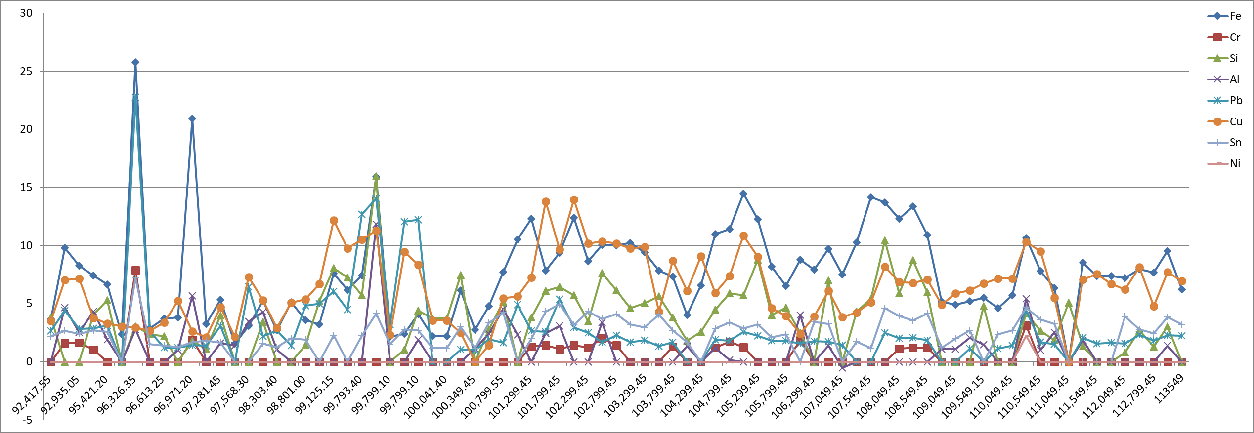
Wear metal

ppm

Total Running hrs

Viscosity
At 40 ºC
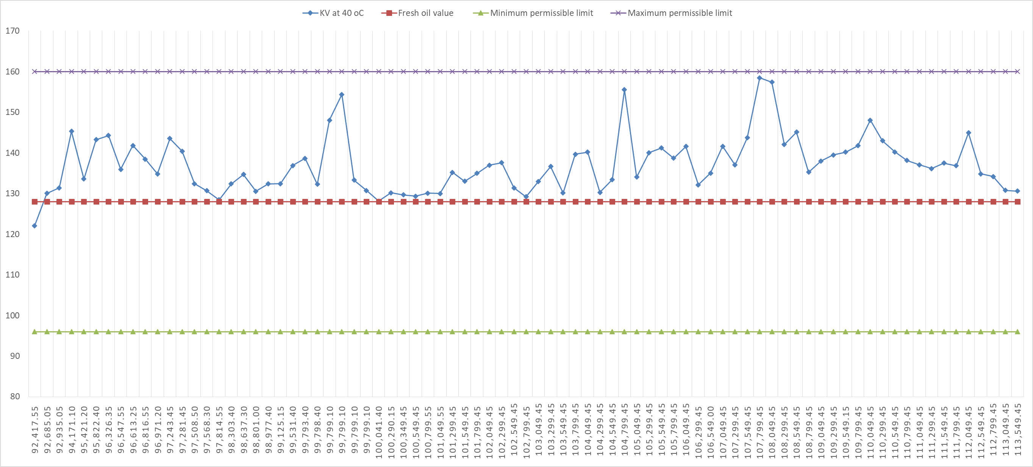

cSt

Total Running hrs

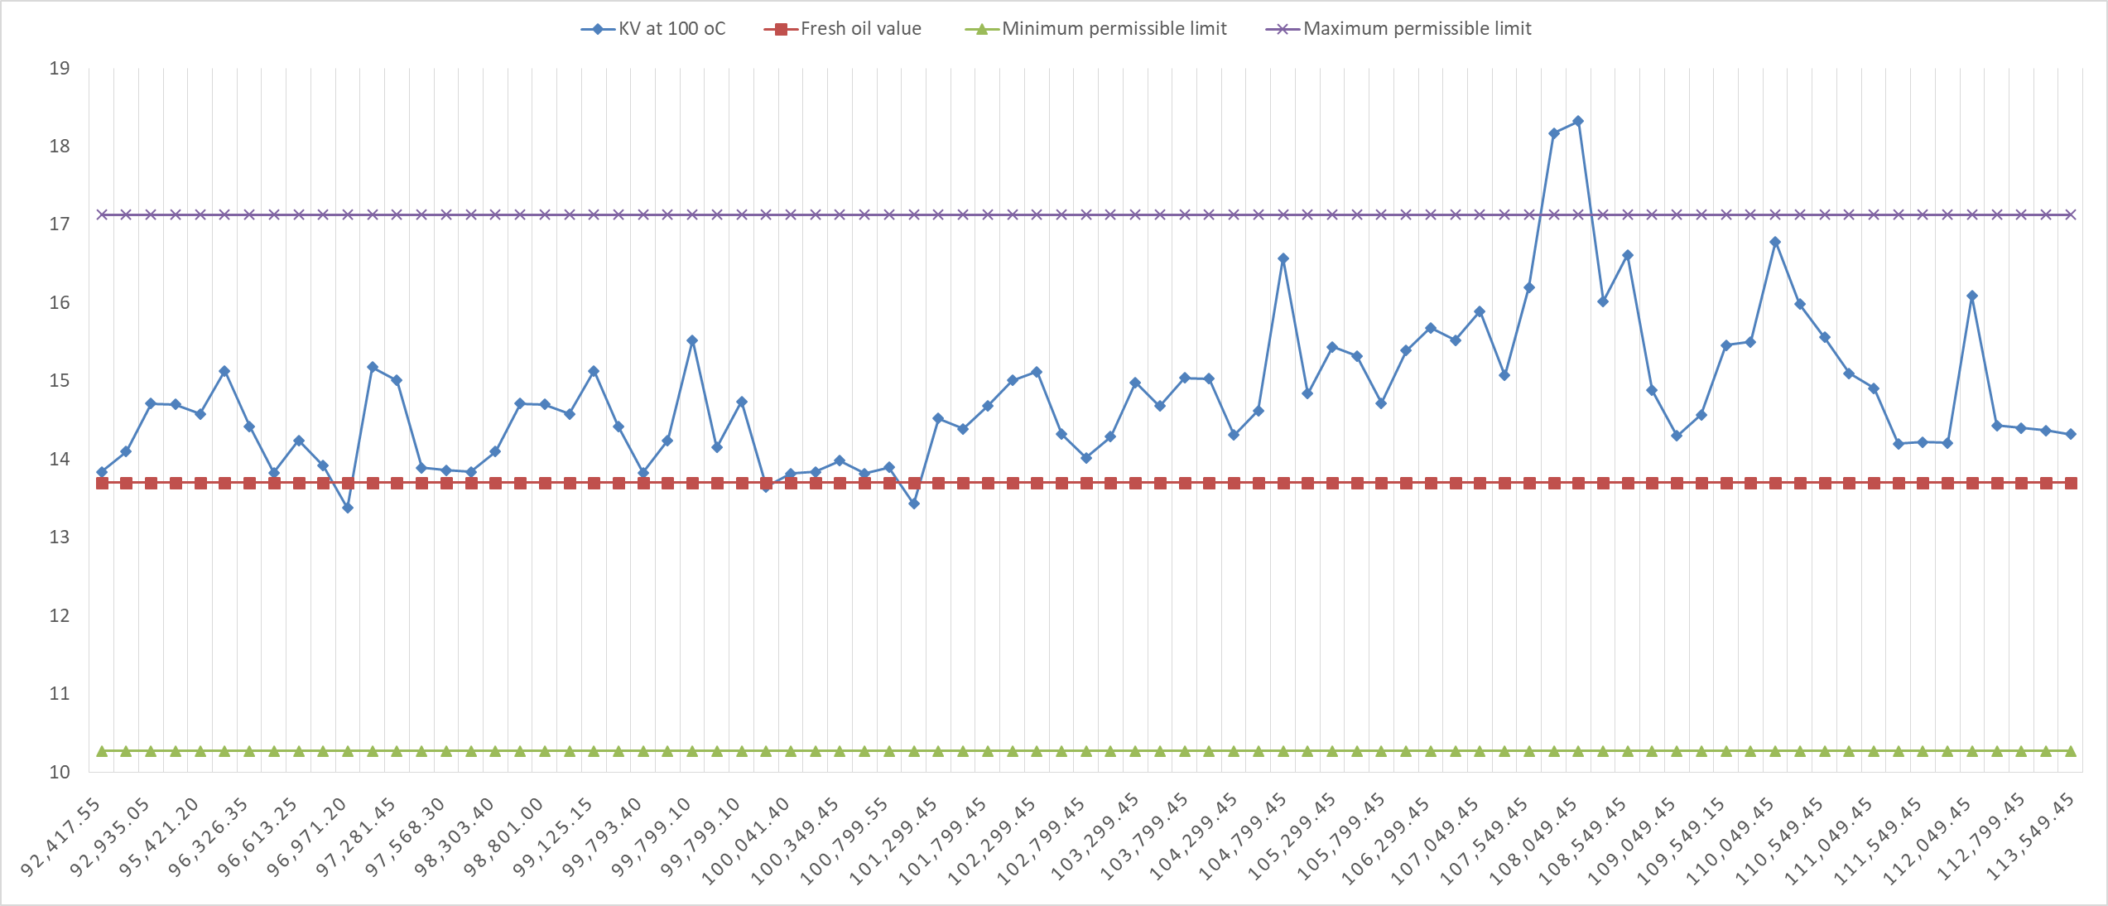
At 100 ºC

cSt

Total Running hrs

